Rabbits as Indoor Pets
10 reasons why bunnies should be housed indoors
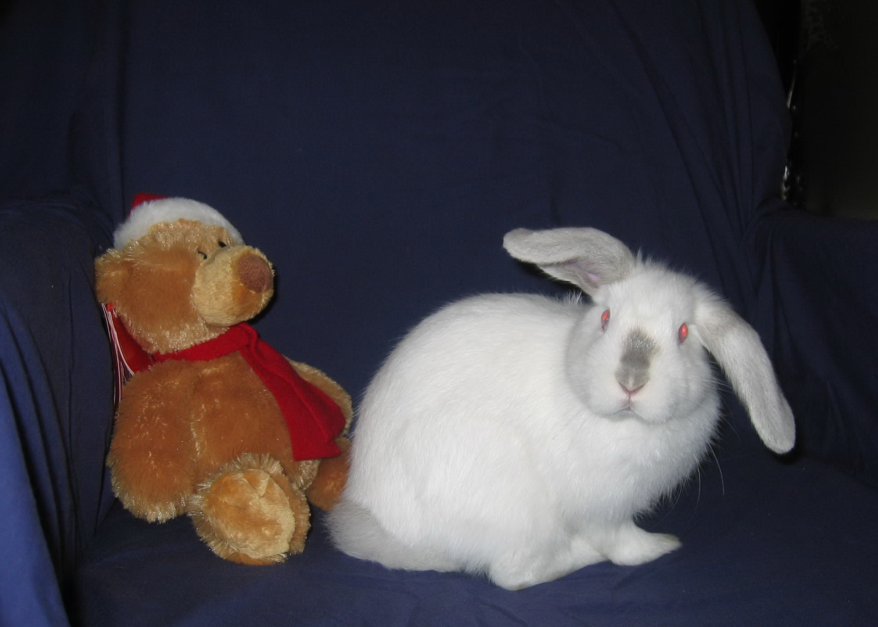
- Rabbits are prey animals They are gentle, intelligent creature and not predator to any other creature. However, they are prey to cats, dogs, foxes, snakes and birds. Yes, there are foxes in the suburbs.
- Rabbits have sensitive temperaments and are easily frightened and stressed by unfamiliar noise or animals and people in their surroundings. They can die from fright and are reliant on their carers to keep them safe and stress free. They see in shapes and will only see a shape approach them. It is important to talk to your bunny so that they recognise your voice as you approach them. The more the bunny is around you the more they will recognise and become used to your voice. A bunny left outside alone in a small hutch will become fearful of you and their surroundings. They mistrust humans if scared and their only defence is to bite to protect themselves. A child poking fingers into the bunny enclosure will also alarm the bunny.
- Rabbits with human interaction are affectionate pets Bunnies learn to trust and will bond with humans the more interaction you have with them. They like routine and will let you know when it is dinnertime.
- Rabbits have sensitive health needs. As a prey animal, bunnies hide illness and it is important to know their habits and what is normal for the bunny. This is evident in disinterest in food, no droppings and sitting quietly hunched and not interested in playing or exploring. Any of these symptoms can result in your bunny dying within a day if not taken to a vet. A house bunny interacts with you daily and you are able to monitor their eating habits and behaviour.
- Rabbits must be protected from mosquitoes and are prone to contracting the calici and myxomatosis virus carried by mosquitoes and other insects. The government has released a new strain of myxomatosis to control wild rabbit populations and there is no vaccine available for pet rabbits. Bunnies can be vaccinated against the calici virus.
- Rabbits can die in the heat and cold. Bunnies do not have sweat glands and do not perspire. Temperatures above 25 degrees can be fatal. Alternatively exposure to wind and rain can also be detrimental. Bunnies should not be left in direct sun. In their natural state they would retreat into cool burrows in the heat of the day.
- Rabbits can be litter trained and are clean animals, they use their litter trays more and more once they are desexed. Desexing protects the girls from uterine cancers, which has an 80% mortality rate and calms the aggressive and anti social behaviours in both sexes that results from puberty.
- Rabbits are social animals. The more that you interact with your bunny the more they will learn to trust you and become inquisitive and affectionate and interactive.
- Rabbits do not need a hutch All they need is a fenced area in the family room, for when you want to contain the bunnies, with a cat house, a bunny tunnel, a litter and hay tray and a sturdy bowl of water. When you are home the bunnies can have a run around and interact with the family.
- Rabbits are affective, inquisitive and interactive family pets in response to human kindness.

